

**COMSATS Institute of Information Technology,**

**Park Road, Chak Shahzad, Islamabad Pakistan**

**Android Navigation App for Blinds**

***By***

**Ahmed Khateeb CIIT/SP12-BCS-028/ISB**

***Supervisor*Miss Faiza Tahir**

***Bachelor of Science in Computer Science (2012-2016)***

**The candidate confirms that the work submitted is their own and appropriate  
 credit has been given where reference has been made to the work of others**.

** COMSATS Institute of Information Technology,**

**Park Road, Chak Shahzad, Islamabad Pakistan**

**Android Navigation App for Blinds**

***By***

**Ahmed Khateeb CIIT/SP12-BCS-028/ISB**

***Supervisor*Miss Faiza Tahir**

***Bachelor of Science in Computer Science (2012-2016)***

**The candidate confirms that the work submitted is their own and appropriate  
 credit has been given where reference has been made to the work of others**.



**COMSATS Institute of Information Technology,**

**Park Road, Chak Shahzad, Islamabad Pakistan**

**Android Navigation App for Blinds**

**A project presented to**

**COMSATS Institute of Information Technology, Islamabad**

**In partial fulfillment**

**of the requirement for the degree of**

***Bachelors of Science in Computer Science (2012-2016)***

**By**

**Ahmed Khateeb CIIT/SP12-BCS-028/ISB**

**DECLARATION**

We hereby declare that this software, neither whole nor as a part has been copied out from any source. It is further declared that we have developed this software and accompanied report entirely on the basis of our personal efforts. If any part of this project is proved to be copied out from any source or found to be reproduction of some other. We will stand by the consequences. No Portion of the work presented has been submitted of any application for any other degree or qualification of this or any other university or institute of learning.

Ahmed Khateeb

---------------------------

**CERTIFICATE OF APPROVAL**

It is to certify that the final year project of BS (CS) “Travelling Tool for Blind” was developed by “**Ahmed Khateeb (CIIT/SP12-BCS-028)**” under the supervision of “Miss Faiza Tahir” and that in their opinion; it is fully adequate, in scope and quality for the degree of Bachelors of Science in Computer Sciences.

---------------------------------------

**Supervisor**

---------------------------------------

**External Examiner**

---------------------------------------

**Head of Department**

**(Department of Computer Science)**

**Executive Summary**

I Blind people need someone's support to travel from one place to another. If they need to go to their desired destination using public transport then they will need someone to tell them about the bus stop. In bus they need someone to guide them repeatedly about the intended end of their journey, like, how far their destination is, either they are in right bus or not, either they have to leave the bus in current stop or not etc.

This project is based on Android. This app will be linked with Android's voice assistant "Google Now" which will help our app to launch by voice input even if the phone is locked, this means that user don't have to open the app manually. When the app will be launched, it will tell the user about their current location, weather condition and temperature. When the user will double tap anywhere on the screen, our app will become ready to get input. App will work according to the input. For example, user says, "Set destination, Blue Area", then app will ask for the confirmation, set the destination and will tell the estimated time. Then app will guide the user about the route on every turn. If the user will divert from the path specified, our app will give vibration feedback and let the user know. Moreover, when the user will pass by special objects like hospital, bus stop, restaurants etc, then the app will tell them, e.g.: "There is a hospital on your left after 100 meters" all by voice.

.

**Acknowledgement**

All praise is to Almighty Allah who bestowed upon us a minute portion of His boundless knowledge by virtue of which we were able to accomplish this challenging task.

I’m greatly indebted to our project supervisor “Miss Faiza Tahir”. Without their personal supervision, advice and valuable guidance, completion of this project would have been doubtful. We are deeply indebted to them for their encouragement and continual help during this work.

And I’m also thankful to my parents and family who have been a constant source of encouragement for us and brought us the values of honesty & hard work.

Ahmed Khateeb

---------------------------

**Abbreviations**

|  |  |
| --- | --- |
| **SRS** | Software Require Specification |
| **App** | Application |
| **FYP** | Final Year Project |
| **ICP** | Introduction to Computer Programming |
| **OOP** | Object Oriented Programming |
| **DS** | Data Structure |
| **SE** | Software Engineering |

**Table of Contents**

**Introduction 1**

1.1 Brief 2

1.2 Relevance to Course Modules 2

1.3 Porject Background 3

1.4 Literature Review 3

1.5 Methodology and Software Life Cycle 5

**Problem Definition** 6

2.1 Problem Statement 7

2.2 Deliverable and Development Requirments 7

**Requirement Analysis** 9

3.1 Functional Requirments 10

3.2 Non – Functional Requirments 11

3.2.1 Usability 11

3.2.2 Reliability 11

3.2.3 Performance 11

3.2.4 Supportability 11

3.2.5 Design Constraints 11

3.2.6 Licensing Requirements 11

3.3 Use case Model 12

3.3.1 Use Case Diagarm 12

3.3.2 Actors Discription 16

3.3.3 Use Case Discription 17

**The Design** 21

4.1 UML Structural Diagrams 22

4.1.1 Component Diagram 22

4.1.2 System Component Diagram 24

4.1.3 Package Diagram 25

4.1.4 Deployment Diagram 26

4.2 UML Behavioral Diagrams 27

4.2.1 Activity Diagrams 27

4.2.2 State Machine Diagrams 29

4.3 UML Interaction Diagrams 30

4.3.1 Sequence Diagrams 30

4.4 Node Structure 31

4.5 Communication Design Protocol 32

**Imlementation** 33

5.1 Communication Protocol Implementation 34

5.2 PC Application Implementation 36

5.3 Embedded Application Implementation 38

5.4 Wireless Sensor Application Implementation 51

**Testing and Evaluation** 52

6.1 Verification 53

6.1.1 Functional Testing 53

6.1.2 Static Testing 57

6.2 Validation 57

6.3 Usability Testing 57

6.4 Unit Testing 57

* 1. Integration Testing 57

6.6 System Testing 57

**GUI** 58

**Future Work** 70

**References** 72

**List of Figures**

Fig 1.1 Block Diagram 8

Fig 2.1 Use Case Diagram 9

# Chapter 1: Introduction

# Brief

This project will help blind people to navigate and travel from source to destination all by voice input/output and vibration feedback as they can understand the voice and feel the vibration feedback.

# Relevance to Course Modules

This project is related to the following courses I’ve studied during BS,

1. **ICP:** Programming knowledge was necessary to complete this project.
2. **OOP:** This project is based on Object Oriented Concepts.
3. **DS and Algorithms:** Instant voice response will be needed.
4. **SE:** So that the project will be complete in time and available resources.
5. **Networking:** Communication with GPS/Server’s location.

# Project Background

This project is based on Google Maps, it is the best map’s SDK out there for Android Apps. Google Maps is a web mapping service developed and supported by Google. The service's frontend utilizes JavaScript, XML and AJAX.

By using the Google Maps API, it is possible to embed Google Maps site into an external website and app, on to which it specific data can be overlaid.

I’ll use Google Map’s API in this project to get the map and draw & manipulate that map. Then I’ll add my own additional functionality according to the project and convert the navigation module and some triggers to voice.

# Literature Review

Google’s map application named “Google Maps” is the best application on Android platform, Maps.me is also the very good product in this genre. But both applications doesn’t have fully enabled voice assistance.

Project “Be my Eye” doing good job in the market, its goal is same as our, but functionality and implementation is different.

# Analysis from Literature Review (in the context of your project)

Google Maps somehow have the voice input option, but it just convert the voice into text just into the search text field. On the other hand, we should be afraid of the project “Be my Eye” but luckily it is not available on Android.

# Methodology and Software Lifecycle for This Project

I’ve used "Incremental Model" in the development life cycle of our project.

* + 1. Rationale behind Selected Methodology

I’ve used Incremental Model because I’ve divided this project in different modules and each module is developed separately. More importantly, I didn’t wanted to wait for the completion of all modules to test the working project, I complete the module, integrate it in project and see the partially working project.

**Chapter 2: Problem Definition**

# Problem Statement

Blind people need someone's support to travel from one place to another. If they need to go to their desired destination using public transport then they will need someone to tell them about the bus stop. In bus they need someone to guide them repeatedly about the intended end of their journey, like, how far their destination is, either they are in right bus or not, either they have to leave the bus in current stop or not etc.

# Deliverables and Development Requirements

Deliverables and development requirements are

**2.2.1 Deliverables**

***2.2.1.1 Project Management Schedule***

A complete Project Management Schedule of all the activities that we have performed in the development of this project.

***2.2.1.2 Project Report***

A complete Project Report that includes Software Requirements Specification, Software Design Specification, GUI Mockups, Test Cases, and other major tasks that we will or have performed.

***2.2.1.3 Source Code***

A CD package including the source code, documentation and presentations.

**2.2.2 Development Requirements**

Following are the requirements that are pre-requisite for running this system.

***2.2.2.1 OS Requirements***

Android OS version 4.0 or higher.

***2.2.2.2 Application Requirements***

Minimum requirement of system to run Google Play Services.

# Chapter 3: Requirement Analysis

# Use Cases

**Launch Application**

|  |  |  |
| --- | --- | --- |
| **Use Case ID:** | UC-01 | |
| **Use Case Name:** | Launch Application | |
| **Actors:** | | User |
| **Description:** | | Very initial step of application life cycle, application will be launched using user’s voice. User have to give specific command i.e. “Ok Google, open Take Me Out”. |
| **Trigger:** | | Giving voice input “Ok Google, open Take Me Out” |
| **Preconditions:** | | 1. Google Now Services must be installed on device. 2. Application must be linked with Android’s Google Now service”. |
| **Postconditions:** | | 1. Application will be launched. 2. Application will tell about the weather condition through voice output. |
| **Normal Flow:** | | 1. User will say “Ok Google, open Take Me Out” 2. Application will be launched. |
| **Alternative Flows** | | None |
| **Exceptions:** | | 1. Google Now service isn’t installed. 2. Google Now service is disabled. 3. Application is not linked with Google Now. |
| **Includes:** | | Speech to Text converter. |
| **Special Requirements:** | | None. |
| **Assumptions:** | | User can speak and understand basic English. |
| **Notes and Issues:** | | None. |

**Set Destination**

|  |  |  |
| --- | --- | --- |
| **Use Case ID:** | UC-02 | |
| **Use Case Name:** | Set Destination | |
| **Actors:** | | User |
| **Description:** | | This will set the destination point on the Map where user wants to go. |
| **Trigger:** | | Double tap anywhere on the screen. |
| **Preconditions:** | | 1. Application must be launched. 2. Application must be in getting input state (Double tap on screen takes application to input state). |
| **Postconditions:** | | 1. Map identifies the destination. 2. Map will find the route between user’s location and identified destination. |
| **Normal Flow:** | | 1. User launch the application. 2. User set the location. |
| **Alternative Flows:** | | None. |
| **Exceptions:** | | 1. Map is unable to identify destination. 2. Voice Assistant doesn’t catch the phrase said by the user. |
| **Includes:** | | Speech to Text converter |
| **Special Requirements:** | | None |
| **Assumptions:** | | User can speak and understand basic English. |
| **Notes and Issues:** | | None. |

**Start Tracking**

|  |  |  |
| --- | --- | --- |
| **Use Case ID:** | UC-03 | |
| **Use Case Name:** | Start Tracking | |
| **Actors:** | | User |
| **Description:** | | Application will start tracking the user’s location and will give feedbacks e.g. turn left after 100 meters etc. |
| **Trigger:** | | Voice command “Go”. |
| **Preconditions:** | | 1. Destination must be identified. |
| **Postconditions:** | | 1. Application will start giving the voice feedback throughout the route. |
| **Normal Flow:** | | 1. User launch the application. 2. User set the location. 3. User say “Go” to start tracking. |
| **Alternative Flows:** | | None. |
| **Exceptions:** | | 1. Voice Assistant doesn’t catch the phrase said by the user. |
| **Includes:** | | Speech to Text converter |
| **Special Requirements:** | | None |
| **Assumptions:** | | User can speak and understand basic English. |
| **Notes and Issues:** | | None. |

**Wrong Direction Identification**

|  |  |  |
| --- | --- | --- |
| **Use Case ID:** | UC-04 | |
| **Use Case Name:** | Wrong Direction Identification | |
| **Actors:** | | User |
| **Description:** | | When user deviate from calculated path then application give the vibration and voice feedback that they are on wrong path. |
| **Trigger:** | | GPS |
| **Preconditions:** | | 1. User should not be on the identified route. |
| **Postconditions:** | | 1. Vibration and voice feedback. |
| **Normal Flow:** | | 1. User launch the application. 2. User set the location. 3. User say “Go” to start tracking. 4. User deviate from identified route. |
| **Alternative Flows:** | | None. |
| **Exceptions:** | | None. |
| **Includes:** | | Speech to Text converter |
| **Special Requirements:** | | None |
| **Assumptions:** | |  |
| **Notes and Issues:** | | None. |

**Estimated Time Calculation**

|  |  |  |
| --- | --- | --- |
| **Use Case ID:** | UC-05 | |
| **Use Case Name:** | Estimated Time Calculation | |
| **Actors:** | | User |
| **Description:** | | Application will continuously calculate the estimated time to reach destination and keep on telling the user. |
| **Trigger:** | | Change in location. |
| **Preconditions:** | | 1. Identified destination. 2. Identified route. 3. User must move (change in longitude and latitude). |
| **Postconditions:** | | 1. Calculated estimate time. |
| **Normal Flow:** | | 1. User launch the application. 2. User set the location. 3. User say “Go” to start tracking. 4. User deviate from identified route. |
| **Alternative Flows:** | | None. |
| **Exceptions:** | | None. |
| **Includes:** | | Speech to Text converter |
| **Special Requirements:** | | None |
| **Assumptions:** | | None. |
| **Notes and Issues:** | | None. |

**Distance Calculation**

|  |  |  |
| --- | --- | --- |
| **Use Case ID:** | UC-06 | |
| **Use Case Name:** | Distance Calculation | |
| **Actors:** | | User |
| **Description:** | | Application will continuously calculate the remaining distance to reach destination and keep on telling the user. |
| **Trigger:** | | Change in location. |
| **Preconditions:** | | 1. Identified destination.   1. Identified route. 2. User must move (change in longitude and latitude). |
| **Postconditions:** | | 1. Calculated distance. |
| **Normal Flow:** | | 1. User launch the application. 2. User set the location. 3. User say “Go” to start tracking. 4. User should start moving. |
| **Alternative Flows:** | | None. |
| **Exceptions:** | | None. |
| **Includes:** | | Speech to Text converter |
| **Special Requirements:** | | None |
| **Assumptions:** | | None. |
| **Notes and Issues:** | | None. |

**Listen to Help**

|  |  |  |
| --- | --- | --- |
| **Use Case ID:** | UC-07 | |
| **Use Case Name:** | Listen to Help | |
| **Actors:** | | User |
| **Description:** | | User can ask help from the application to get proper information to operate application. |
| **Trigger:** | | Triple tap on screen. |
| **Preconditions:** | | 1. Application must be launched. |
| **Postconditions:** | | 1. Voice Assistant entertain user with help. |
| **Normal Flow:** | | 1. User launch the application. 2. User triple tap on screen. |
| **Alternative Flows:** | | None. |
| **Exceptions:** | | None. |
| **Includes:** | | Speech to Text converter |
| **Special Requirements:** | | None |
| **Assumptions:** | | None. |
| **Notes and Issues:** | | None. |

**Weather Prediction**

|  |  |  |
| --- | --- | --- |
| **Use Case ID:** | UC-08 | |
| **Use Case Name:** | Weather Prediction | |
| **Actors:** | | User |
| **Description:** | | Application will predict the weather condition of the user’s location and destination and will suggest the user to according to weather (e.g. take umbrella with you). |
| **Trigger:** | | Confirmation of destination. |
| **Preconditions:** | | 1. Destination should be identified and selected. |
| **Postconditions:** | | 1. Voice Assistance will tell the weather condition. |
| **Normal Flow:** | | 1. User launch the application. 2. Speech input destination. 3. Search the destination 4. Confirm the destination. |
| **Alternative Flows:** | | None. |
| **Exceptions:** | | None. |
| **Includes:** | | None. |
| **Special Requirements:** | | None |
| **Assumptions:** | | None. |
| **Notes and Issues:** | | None. |

# Functional Requirements

|  |  |
| --- | --- |
| Set Destination | Application will allow user to set specific destination to keep them on right track to reach there. |
| Weather Prediction | Application will predict the weather condition of the user’s location and destination and will suggest the user to according to weather (e.g. take umbrella with you). |
| Distance Calculation | The application will provide the feature of calculating the distance between user’s location and destination and will keep on calculating the time when the user start moving to destination. |
| Track User | Application will keep track of user while navigation. |
| Time Calculation | The application will provide the feature of calculating the remaining estimated time to reach the destination. |
| Wrong Path Detection | Application will detect weather the user is going through the right path or not. |

**Set Destination**

|  |  |
| --- | --- |
| Identifier | FR1 |
| Title | Set Destination |
| Requirement | Application will allow user to set specific destination to keep them on right track to reach there. |
| Source | Application User |
| Rationale | So that the application help the user to their desired location. |
| Restrictions and Risk | Proper voice input and the pronunciation should be understand able by Voice Assistant. |
| Dependencies | None |
| Priority | High |

**Weather Prediction**

|  |  |
| --- | --- |
| Identifier | FR2 |
| Title | Weather Predication |
| Requirement | Application will predict the weather condition of the user’s location and destination and will suggest the user to according to weather (e.g. take umbrella with you). |
| Source | Application User |
| Rationale | This requirement helps user to decide whether he/she is ready to start their journey or not. |
| Restrictions and Risk | This information might not be accurate. |
| Dependencies | F1 |
| Priority | Medium |

**Distance Calculation**

|  |  |
| --- | --- |
| Identifier | FR3 |
| Title | Distance calculation |
| Requirement | The application will provide the feature of calculating the distance between user’s location and destination and will keep on calculating the time when the user start moving to destination. |
| Source | Application User |
| Rationale | This requirement let user know where to take a turn and where do they stop. |
| Restrictions and Risk | Actual distance might vary with in 20 meters. |
| Dependencies | F1, F4 |
| Priority | High |

**Track User**

|  |  |
| --- | --- |
| Identifier | FR4 |
| Title | Track User |
| Requirement | Application will keep track of user while navigation. |
| Source | Application User |
| Rationale | This requirement will let the user know how much time will need them to reached to the destination, whether they are on right path or not, when they have to change their direction and what is the remaining time to reach to their destination, |
| Restrictions and Risk | Actual location might vary within 20 meters. |
| Dependencies | F1, F3 |
| Priority | High |

**Time Calculation**

|  |  |
| --- | --- |
| Identifier | FR5 |
| Title | Time Calculation. |
| Requirement | The application will provide the feature of calculating the remaining estimated time to reach the destination. |
| Source | Application User. |
| Rationale | So that the user should know how much time is needed to reach their desire location. |
| Restrictions and Risk | Proper voice input and the pronunciation should be understand able by Voice Assistant. |
| Dependencies | None. |
| Priority | Low. |

**Wrong Path Detection**

|  |  |
| --- | --- |
| Identifier | FR6 |
| Title | Wrong Path Detection |
| Requirement | Application will detect weather the user is going through the right path or not. |
| Source | Application User. |
| Rationale | This requirement will let the user know if they are on wrong path and they need to go back to the right path. |
| Restrictions and Risk | Actual distance might vary within 20 meters. |
| Dependencies | None |
| Priority | High |

# Non-Functional Requirements

**3.3.1 Usability**

**User Experience**

|  |  |
| --- | --- |
| US-1 | User Experience (UX) will be user friendly. Voice Assistant will tell user what step should be taken next. |

**3.3.2 Reliability**

**Design**

|  |  |
| --- | --- |
| R-1 | Design of the application is developed according to the best navigation apps in market “Google Maps” and “Maps.me” which are 90% and 85% reliable respectively. |

**Interaction**

|  |  |
| --- | --- |
| AI-1 | User will interact with application through voice. |

**Availability**

|  |  |
| --- | --- |
| AA-1 | Application will be available all the time. |

**3.3.3 Performance**

**Response Time**

|  |  |
| --- | --- |
| RT-1 | The response time of the voice to text converter is 1.5 second. |
| RT-2 | The response time of identifying the current location and destination is 2 seconds. |
| RT-3 | The response time of the text to voice converter is 0.5 second. |

**Throughput**

|  |  |
| --- | --- |
| RP-1 | Throughput of application is less than 4 seconds. |

**3.3.4 Supportability**

**Languages**

|  |  |
| --- | --- |
| SU-1 | Some of coding standards we will use in developing this system will be :   * Java * XML * JASON |

**Tools and Technologies**

|  |  |
| --- | --- |
| SU-2 | We will use following SDK and IDE to build this system:   * Android Studio * Android SDK * Google Map SDK |

**3.3.5 Design Constraints**

**Compatibility**

|  |  |
| --- | --- |
| DC-1 | Application will work on the device running Android 4.0 or higher. |

# Chapter 4: Design and Architecture

This chapter will discuss the design and architecture of your system.

# System Architecture

Explain and justify the choice of system architecture for your project.

# System Design

**4.2.1 Use Case Diagram**

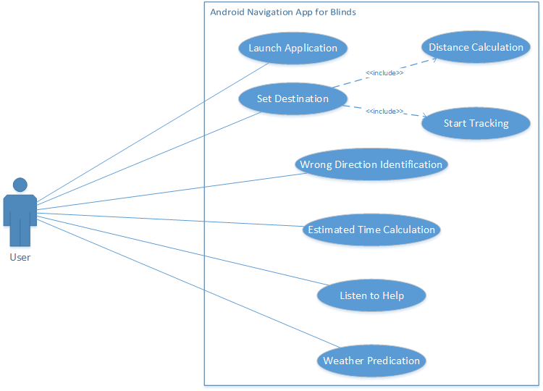

**4.2.2 Activity Diagrams**

1. **Setting Destination**

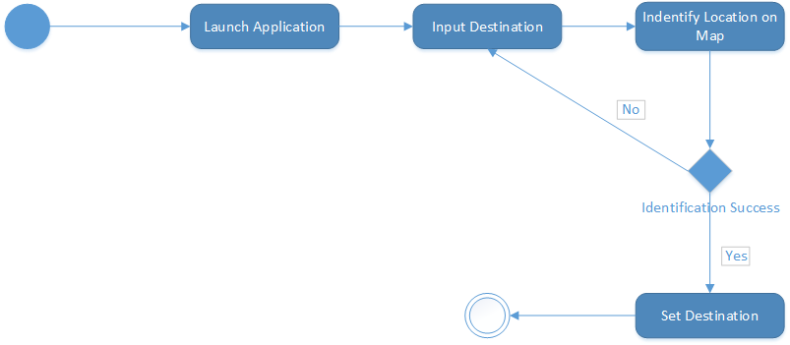

1. **Get Weather Information**

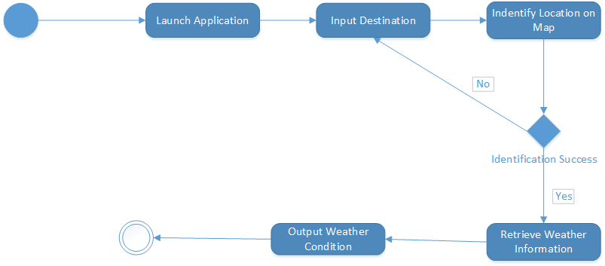

1. **Wrong Direction Detection**

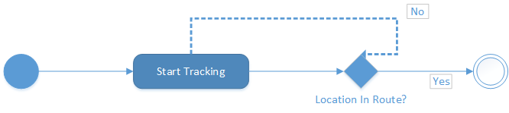

**4.2.3 Class Diagram**

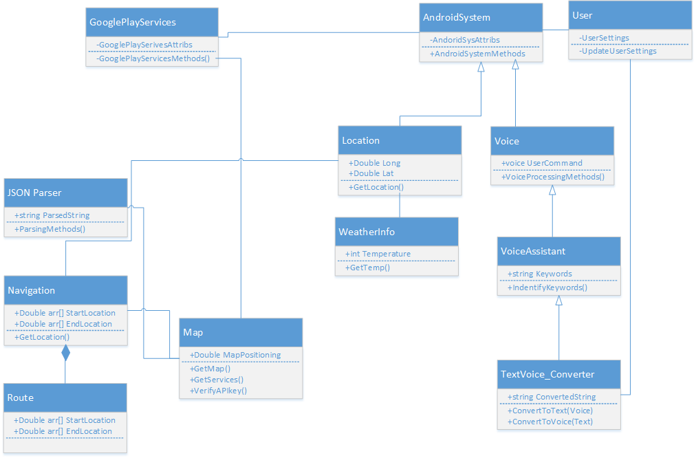

**4.2.4 Sequence Diagrams**

1. **Setting End Points**

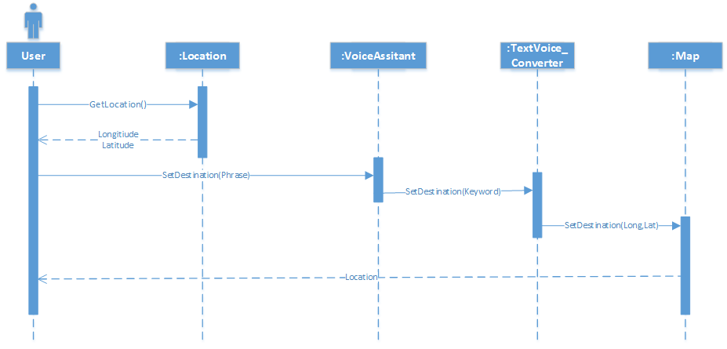

1. **Navigation**

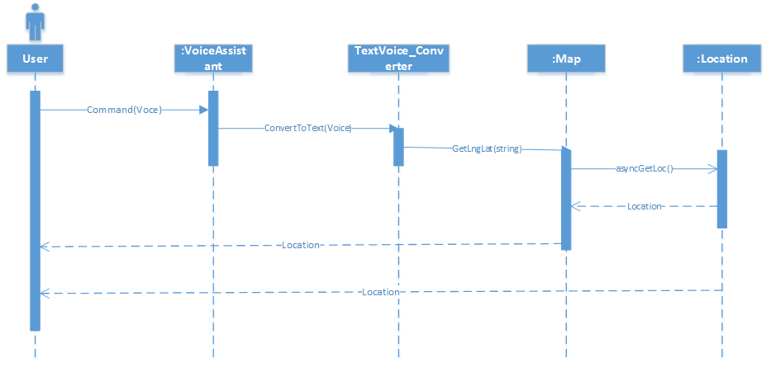

1. **Deviating from Path**

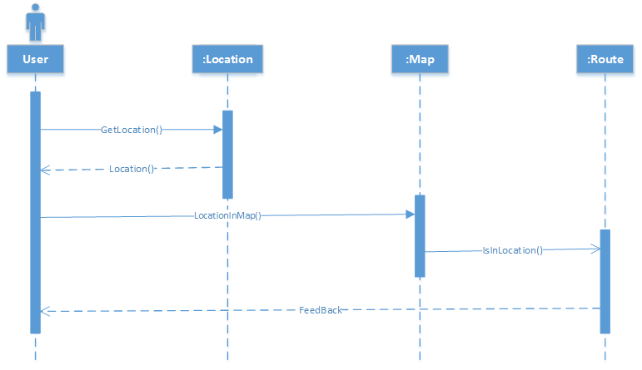

# References

References to any book, journal paper or website should properly be acknowledged. Please consistently follow the style. The following are few examples of different resources i.e. journal article, book, and website.

1 Lyda M.S. Lau, Jayne Curson, Richard Drew, Peter Dew and Christine Leigh, (1999), Use Of VSP Resource Rooms to Support Group Work in a Learning Environment, ACM 99, pp-2. (Journal paper example)

2 Hideyuki Nakanishi, Chikara Yoshida, Toshikazu Nishmora and Turu Ishada, (1996), FreeWalk: Supporting Casual Meetings in a Network, pp 308-314 (paper on web) http://www.acm.org/pubs/articles/proceedings/cscw/240080/p308-nakanishi.pdf

3 Ali Behforooz & Frederick J.Hudson, (1996), Software Engineering Fundamentals, Oxford University Press. Chapter 8, pp255-235. (book reference example)

4 Page Author, Page Title, http://www.bt.com/bttj/archive.htm, Last date accessed. (web site)